1. Information disclosure in error messages 1
2. Information disclosure on debug page 1
3. Source code disclosure via backup files 3
4. Authentication bypass via information disclosure 4
5. Information disclosure in version control history 6

Information disclosure in error messages
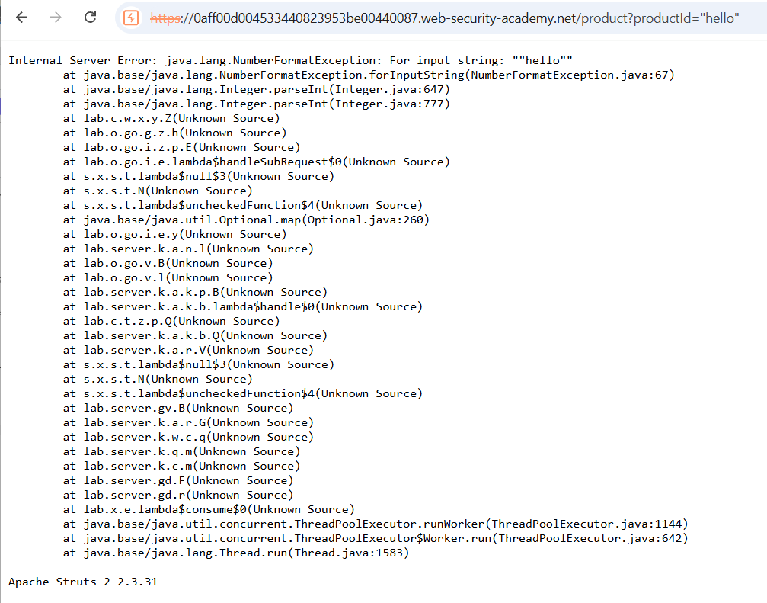

Information disclosure on debug page
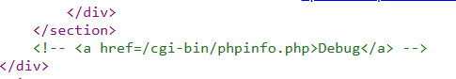
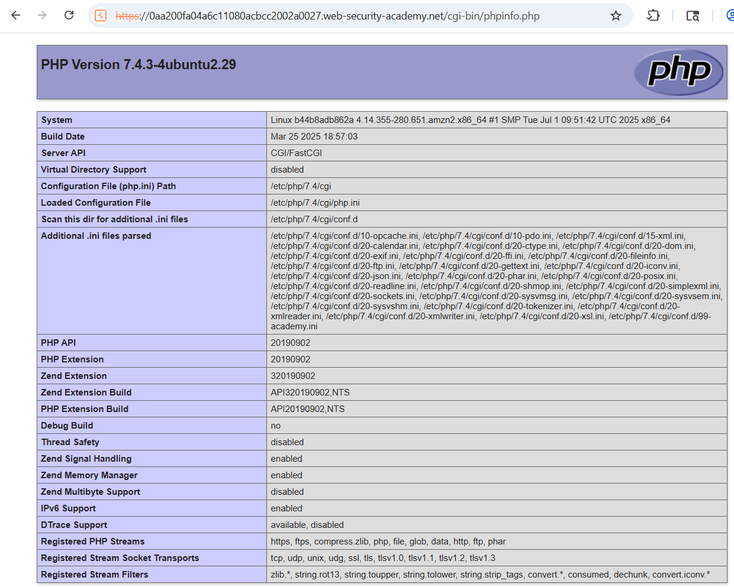
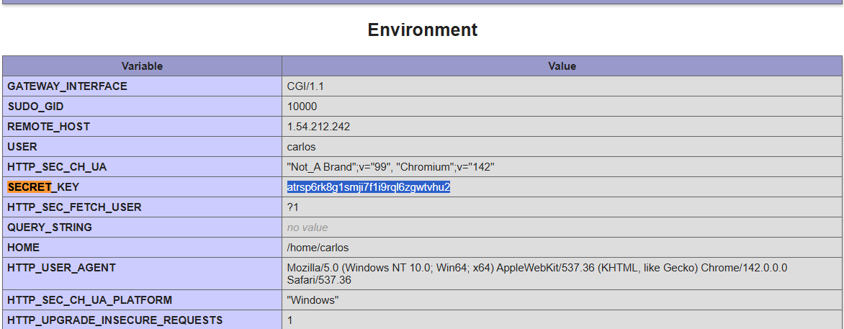

Source code disclosure via backup files
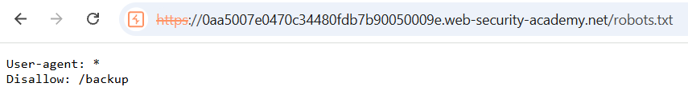
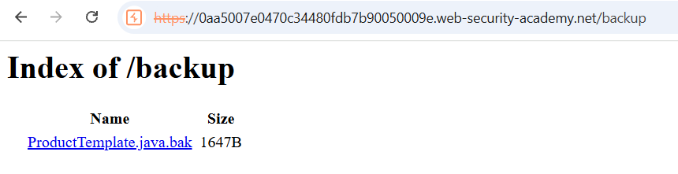
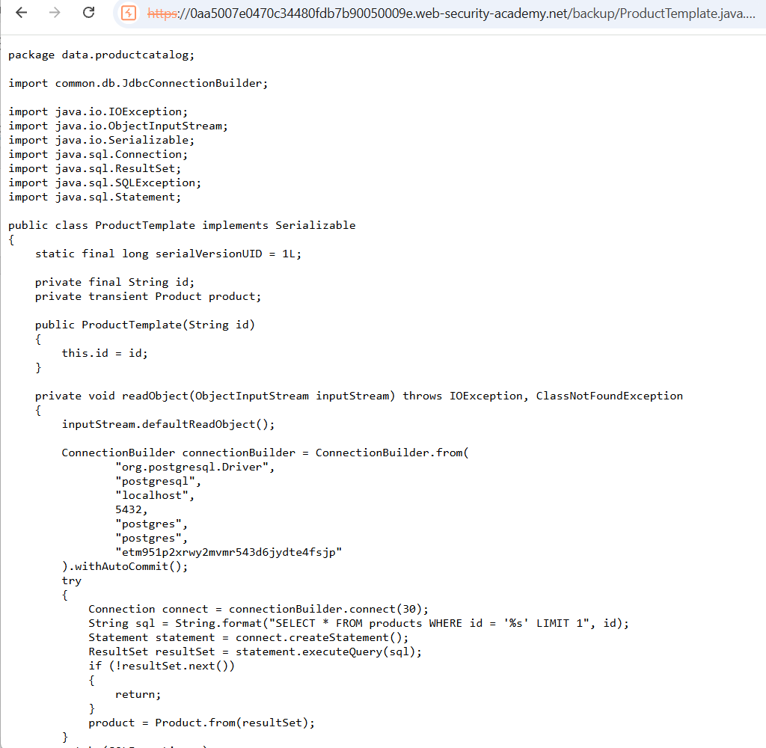

Authentication bypass via information disclosure
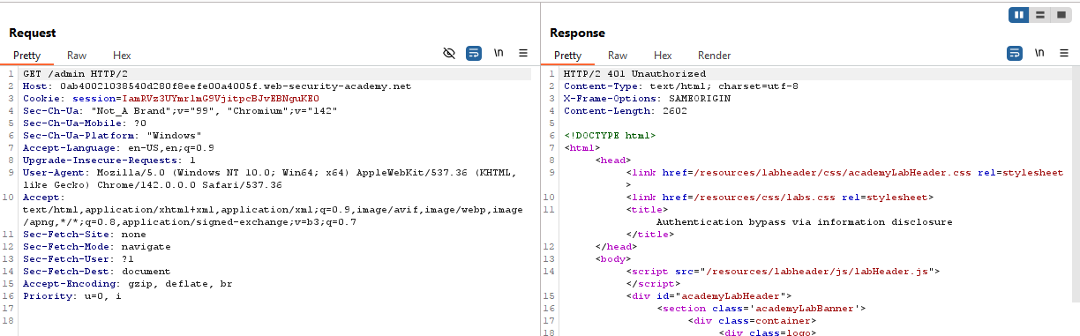
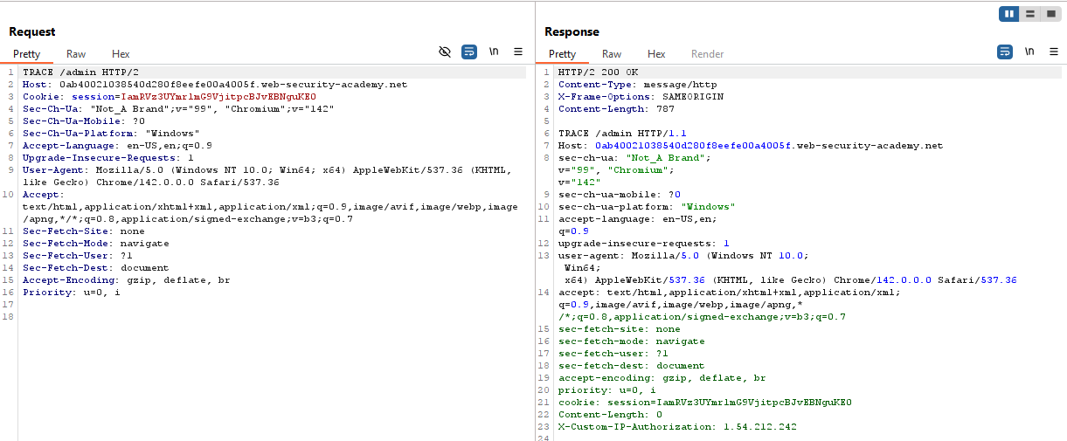
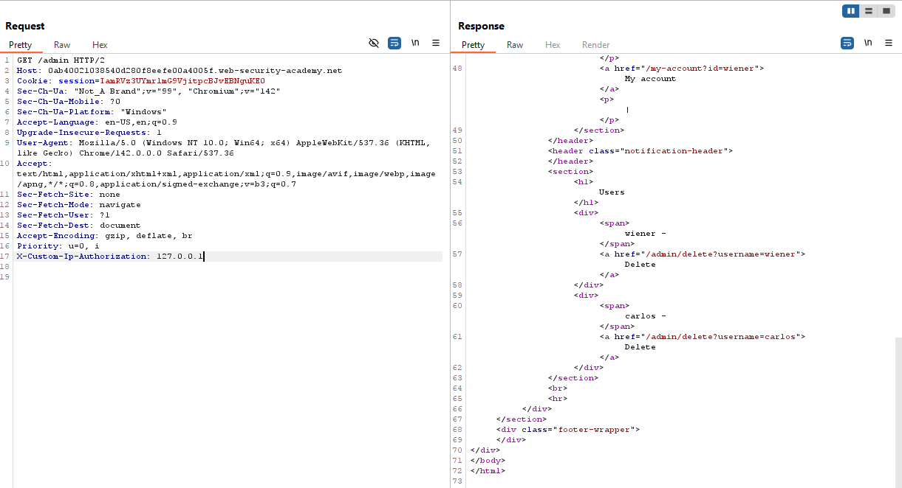
Giờ chúng ta có thể dùng directory như trong reponse để có thể xóa tk carlos hoặc chúng ta có thể làm theo cách khác
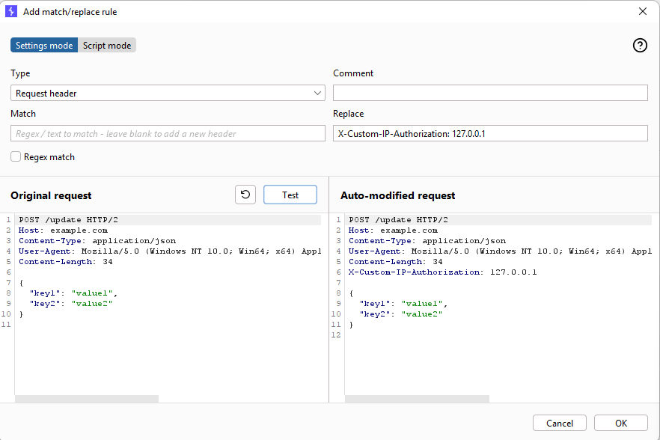
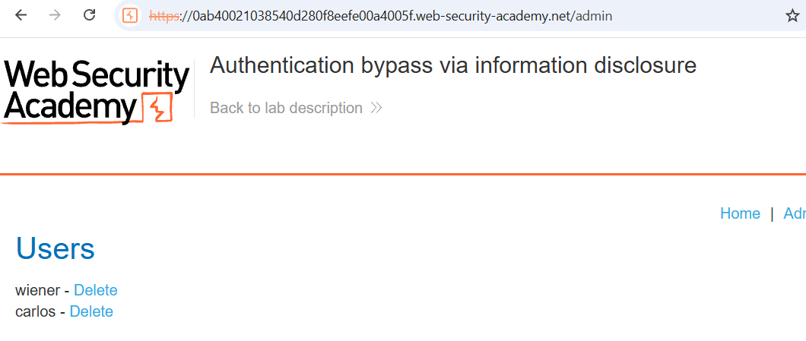

Information disclosure in version control history
